

Reception Weekly Newsletter

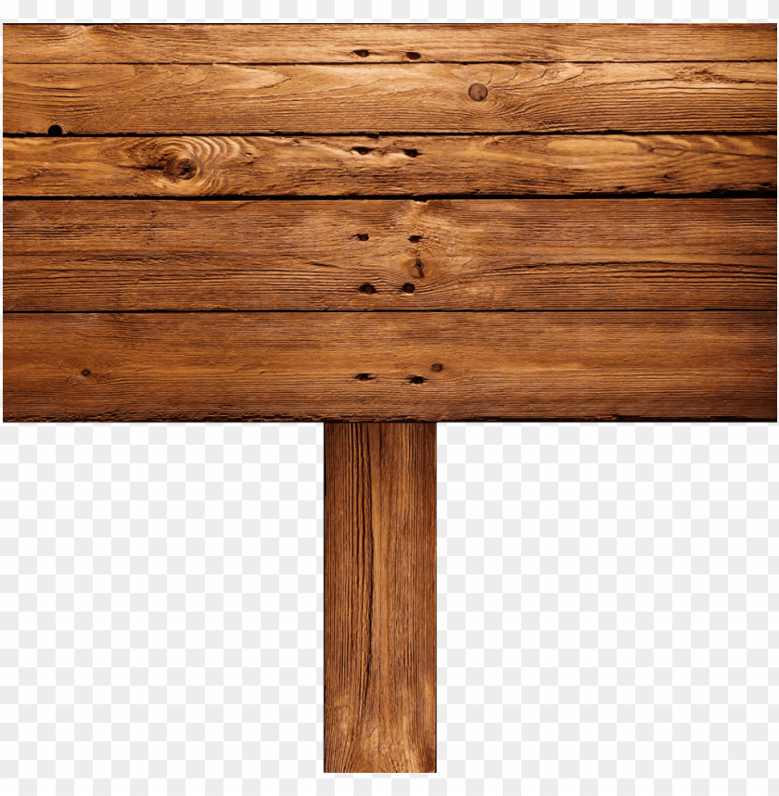 q

Wow Challenge!

Can you make a list of all the things you would need for a party?

You could draw these and write the sounds you can hear in the words.

**This week we have...**

* Started our new learning enquiry – ‘How do people celebrate differently?’
* We have been sharing the story ‘The Scarecrows Wedding’ and writing our own lists.
* Been talking about where we live, we have looked at the globe and found England on it.
* Learnt that in Jamaica they have a birthday tradition of throwing flour over the birthday child’s head.

Friday 26th November 2021