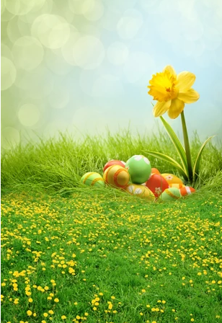

Reception Weekly Newsletter

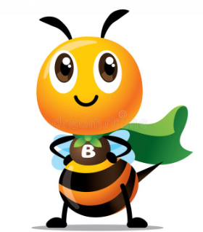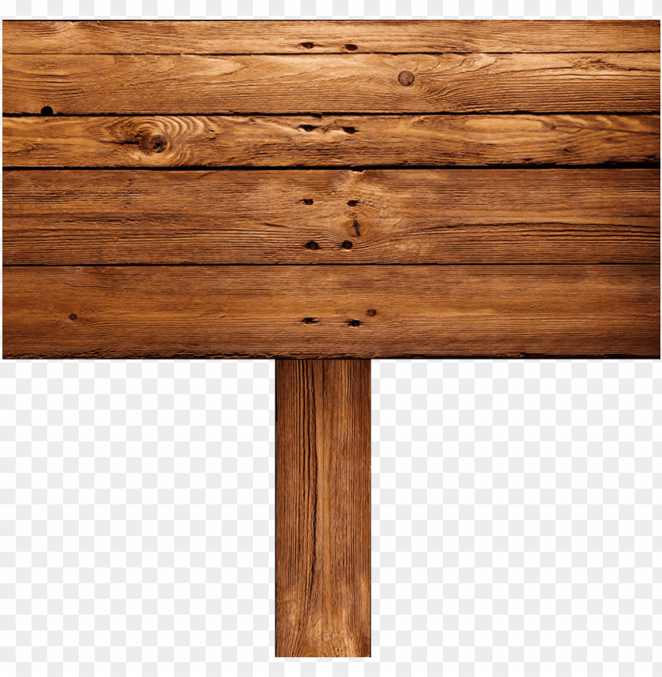 q

Wow Challenge!

Can you write a short story about a minibeast with a super power?

**Dates/things to remember …**

* On Tuesday 24th May we are holding a minibeast day. We will play games, sing minibeast songs and have some minibeast themed treats made by the children. We encourage children to come to school dressed as a minibeast on this day. Please do not feel obliged to buy a costume, there are lots of easy homemade options available on the internet. We also have a local author Mrs Byrne coming in to share her minibeast story with us!

**This week we have...**

* Been practicing different strategies to help us subtract.
* Been reviewing our bee hotel design and final building.
* Been building and writing sentences.
* Used various materials to create minibeasts.

Friday 20th May 2022