Galmpton Church of England Primary
Collective Worship Planner 2021/22

AUTUMN 1 | AUTUMN 2 | SPRING 1 | SPRING 2 | SUMMER 1 | SUMMER 2
CITIZENSHIP | EXPLORATION | EXPRESSION | LEADERSHIP | FLOURISIHING | CITIZENSHIP
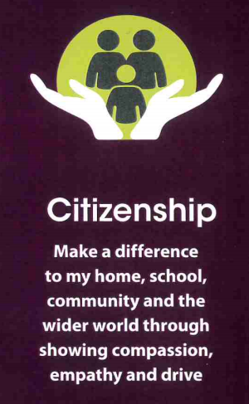 |  |  |  | 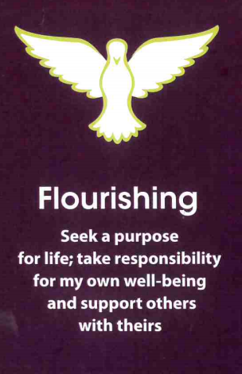
FRIENDSHIP  EMPATHY  DRIVE/DETERMINATION  COMPASSION | COURAGE  INTEGRITY  RESPECT CONFIDENCE | DIGNITY  TRUTHFULNESS/  HONESTY  TRUST GENEROSITY | WISDOM  HOPE  PERSEVERANCE  ASPIRATION | FORGIVENESS  JOY  PEACE  RESPONSIBILITY | COMMUNITY  THANKFULNESS SERVICE  JUSTICE

Rationale for Collective Worship – We consider collective worship to be an integral and essential part of our whole school Vision, ethos and curriculum. It is broadly Christian in nature and inclusive of all pupils. It is a time when the school community can express itself and develop spiritually both as a group and individually. Each half term we use our gateways to guide us through a set of underpinning Christian values. We use the Roots and Fruits Christian values (green) and our Gateway values (purple) to ensure our values led approach to worship is intertwined and linked to our curriculum. All worships will have a theological approach, explaining how the gospels reveal the way in which Jesus embodied these values.
AUTUMN 2021
Week | Theme/Gateway  CITIZENSHIP | Key Ideas/  Concepts  Link to Holy Spirit | Festivals/  Services | Resources  Roots and Fruits- main resource |  | Music | Bible References
Week 1  8.9.21 | Courageous advocacy (drive and empathy) | Love your neighbour as Yourself-the Golden Rule | International day of Charity -5th Sept | RF1 P123 |  | This is my command to you | Matthew 7.12
Week 2  13-9-21 | Courageous advocacy (drive and empathy) | Valuing difference-  respect | 16 September (Thursday) YOM KIPPUR Jewish | RF1 P120 |  | Hiding Place  When I needed a Neighbour | Luke 7. 1-10
Week 3  20-9-21 | Friendship | Sticking together | 21 September (Tuesday) – 28 September (Tuesday) SUKKOT Jewish | RF 1  P97 |  | Taking my time (out of the Ark) | Proverbs 18.24
Week 4  27-9-21 | Friendship | Encouraging one another | 29 September (Wednesday) MICHAELMAS National | RF 1  P100 |  | Together (out of the ark) | 1Thessalonians 5.11
Week 5  4-10-21 | Friendship | Supporting one another |  | RF1 P103 |  | Bind us together Lord | Luke 5.17-39
Week 6  11-10-21 | Friendship | Learning to Listen | 10-17.10 inter faith week of prayer for world peace | RF1 P109 |  | Be Still | Proverbs 17.17
Week 7  18-10-21 | Celebrating Harvest | Brixham food bank-giving to others, giving as God Gives | Harvest  Diwali-19/10 | RF1 p.28 |  | Another Harvest festival  Harvest songs | Psalm 65.13-19
HALF TERM
Week | Theme/Gateway  Exploration | Key Ideas/  Concepts  Link to Holy Spirit | Festivals/  Services | Resources  Roots and Fruits- main resource | Music |  | Bible References
Week 8  1-11-21 | Wisdom | The Wise and Foolish Builders | All Saints Day-1/11 | RF2 P154 | The Wise man built his house upon the rocks |  | Matthew 7.24-27
Week 9  8-11-21 | Wisdom | Jesus meets a Roman centurion | Remembrance Sunday-14/11 | RF2 P192 | Be Thou My Vision |  | Matthew 8.5 – 10.13
Week 10  15-11-21 | Wisdom | The Sower | Anti Bullying week-One Kind Word | RF2 P158 | How Great thou art |  | Luke 8.4-15
Week 11  22-11-21 | Wisdom | The teachers in the Temple | Road Safety Week | RF2 p90 | Dear Lord and Father of Mankind |  | Luke 2.41-50
Week 12  29-11-21 | Respect | Valuing Different opinions | 1st Sunday of Advent-28/11 | RF1 p129 | This is my Command to you |  | 1Peter 2.17
Week 13  6-12-21 | Celebrating Advent | What is Advent? | Christingle Service in church | RF1 p.172 | Light a candle |  | Luke 2.21-40
Week 14  13-12-21 | Celebrating Christmas | God of the unexpected | Christmas service 16/12  Nativity plays this week | RF1 p.48 | Christmas hymns and songs |  | Luke 2.8-20

Mondays- Leadership led worship- KB or another senior leader. Tuesdays- Key Stage worships Wednesdays- Class based Thursdays- Sung worship Fridays- Class Led/celebration worship (fortnightly.)

