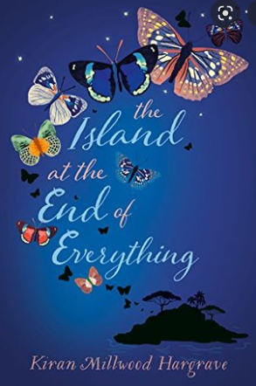 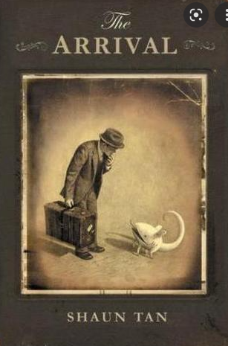

**Our Relationship Education Learning Enquiry in Year 6:**

***‘How can we challenge discrimination and support others?’***

**During our learning enquiry, we will explore how we treat others and the views we hold surrounding discrimination – we will investigate many forms of discrimination, including stereotyping and the plight of refugees, and we will focus on how we can challenge discrimination and support others, especially if we feel they have been discriminated against.**

**English**

**We will be using a picture book called ‘The Island’ by Armin Greder, which depicts how the inhabitants of an island treat a stranger. We will also study a graphic novel called ‘The Arrival’ by Shaun Tan which tells a universal story of migration.**

**In reading,** we will using ‘The Arrival’ at first to focus on comprehension skills and then we will be reading the novel ‘The Island at the End of Everywhere’ to further our reading skills and understanding of discrimination.

**In writing,** we will be using the ‘The Island’ to write our own narratives that challenge discrimination and depict people supporting others.

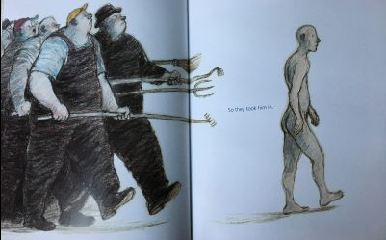

**Mathematics**

**Over the next three weeks we will be focusing on developing our mathematical knowledge and skills by:**

* Reading, writing and ordering numbers to 10 million
* Comparing and ordering any number
* Rounding numbers to 10, 100 and 1000
* Rounding numbers
* Using negative numbers in context

We will also be focusing on learning our multiplication facts and related decimal knowledge.

**Foundation Subjects:**

**P.E** - We will focus on gymnastics and invasion games.

**Music** - We will develop our skills of listening and responding to music. **ICT** - We will develop our understanding social media

**RE** – We will be answering the question ‘Why do some people believe in God and some people not?’

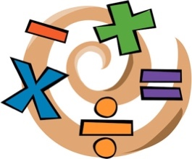

**Our Gateway & Character Value**

