Our Christian Values as a Church School

The School's five Values seek to underpin the Christian belief that we are all God's people and that we all matter. We endeavour to nurture excellence in all that we do; both in our learning, our play and in our relationships. We believe that everyone within our school community should be valued and treated with love and respect and that each of us has a right to grow and become the best we can be. Likewise, we believe that we each have a responsibility to show respect and tolerance towards each other. Our shared Values have been developed and are shared by the whole school community. They are central to what we believe within school and permeate our daily work and interactions, relationships and decisions. With these values and our Mission to ‘Achieve and Flourish Together in God’s loving Arm’s’ we know that our children are being prepared as lifelong learners.

We start to develop Friendships amongst our pupils as soon as they come to Galmpton. Our youngest children are given a buddy from our Year 6 class. Our buddy system seeks to develop friendships between our youngest and eldest pupils and supports our newest children at a time of uncertainty and change. We promote strong friendships throughout the school. The Bible has many sayings about friendship:
‘A friend loves at all times.’ (Proverbs 17:17)
Friends are not afraid to tell each other the truth and a friend’s loving criticism is worth more than the empty compliments of someone who does not really care for you.
‘Wounds from a friend can be trusted, but an enemy multiplies kisses.’ (Proverbs 27:6)

Friendship

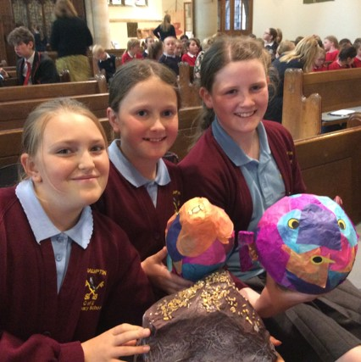

Forgiveness is something that underpins all our relationships at Galmpton. We remind children frequently of the need to forgive and that forgiveness is something that strengthens our friendships. We encourage children to be ready to say sorry and to forgive.
Jesus was uncompromising in his command to forgive. Forgive, he said, ‘seventy times seven’ (Matthew 18:21). In other words, forgive and keep on forgiving without limit.
Forgiveness was at the heart of everything Jesus did and is at the heart of the Lord’s Prayer. When Jesus declared a person’s sins to be forgiven, it often aroused the anger of those who were less willing to forgive than he was and yet a prayer for the forgiveness of his persecutors was on Jesus’ lips as he died.

Forgiveness

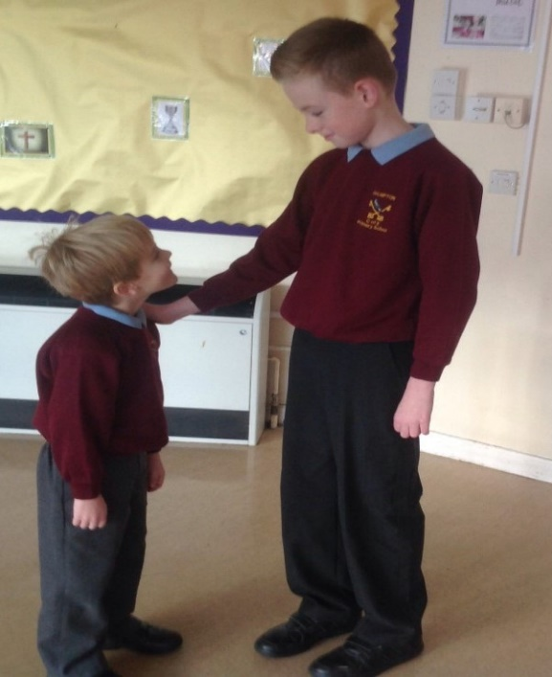
We encourage children to find moments of Peace throughout the school day, most notably during Worship. We also encourage children to be outwardly and inwardly peaceful and at peace. In Jesus’ message, peace is an almost tangible element. It is his gift to his disciples. Paul describes God as the God of peace, the Christian message is called the ’gospel of peace’ and peace is one of the ‘fruits of the Spirit’.
We are called to learn and re-learn the message of peace. It does not come easily or automatically. Peter, quoting the Psalms, says we must ‘seek peace and pursue it’ (1 Peter 3:11). Jesus blesses those who are ‘peacemakers’ and calls them ‘sons of God’.

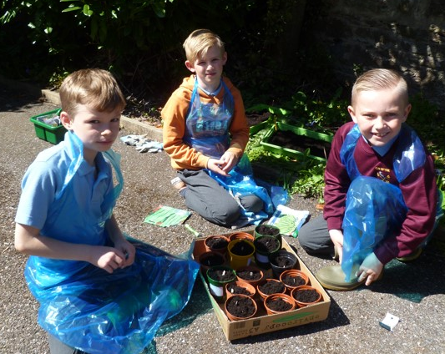
We aim primarily to teach children about the value of Compassion by modelling it ourselves as adults. We do this in the way we interact with all members of our school community. We believe that if we are to flourish we must have a strong sense of compassion, particularly for those who are more in need than ourselves.
We frequently refer to the example of Jesus when we discuss the value of compassion and use the many examples that can be find in the Bible of His Compassion. We particularly draw attention to Jesus’ compassion for the marginalised, the outcasts and those in greatest need.

Compassion

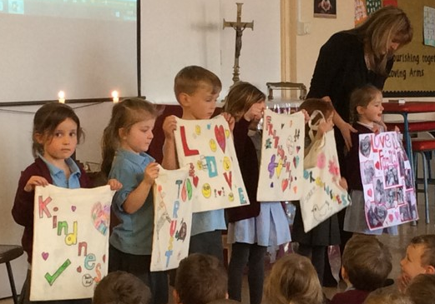

Peace

Trust
Trust is a really important value. It must be earned. If we do not trust someone it is very hard to build a good friendship with them. We frequently talk about why it is important to be trustworthy. We give children practical ways that they can show others that they are trustworthy eg walking in the corridors. We also teach children why it is important to be able to trust others when working together as a team.
"Trust is the very essence of faith; trust in the God who is trustworthy."

